**"toy labels to the rescue"**

I know how it feels when you see the toy clutter like this!

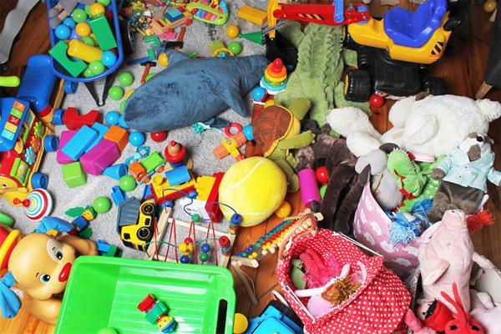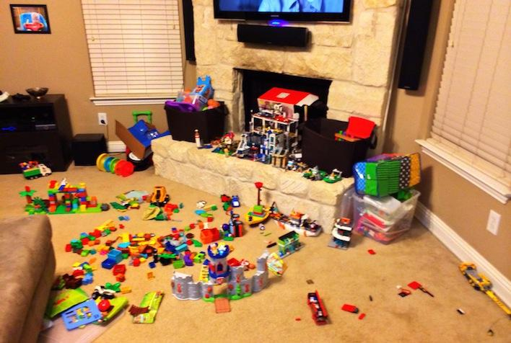

Encouraging children to pick up their toys is a difficult task. I’ve been trying to keep toys organized for quite a few years. I’ve attempted every technique imaginable and to no avail, the mess returns. Finally, I’ve found a system that works for us and it’s [toy storage labels](https://www.amazon.com/dp/B07QX9QL7D?ref=myi_title_dp)!

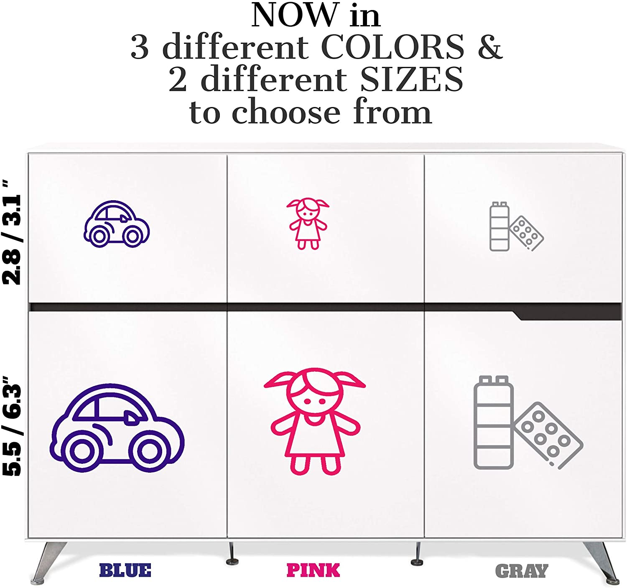

At first, I thought a couple of toy baskets could hold my kids’ toys. But I realized storage is not enough to keep them organized at all times. When my little monsters are trying to look for a specific toy, they would pour all of it from the basket just to pick something and leaves the rest on the floor.

So we came up with the idea of [Toy Storage Labels](https://www.amazon.com/dp/B07QX9QL7D?ref=myi_title_dp) to keep the toys organized and easy to find especially the tiny ones. Ever since we had these amazing [labels](https://www.amazon.com/dp/B07QX9QL7D?ref=myi_title_dp), every car, doll, book, teddy, animal, dino, and all the other ones have their own places!

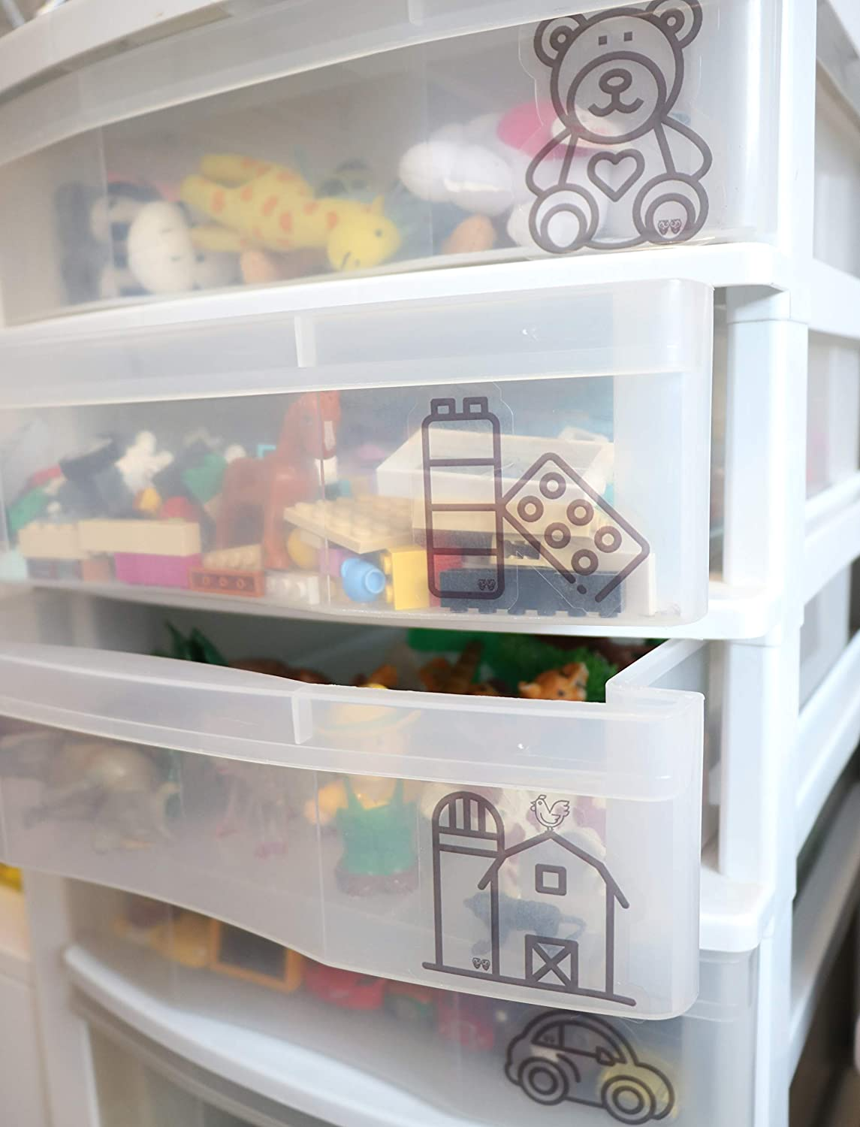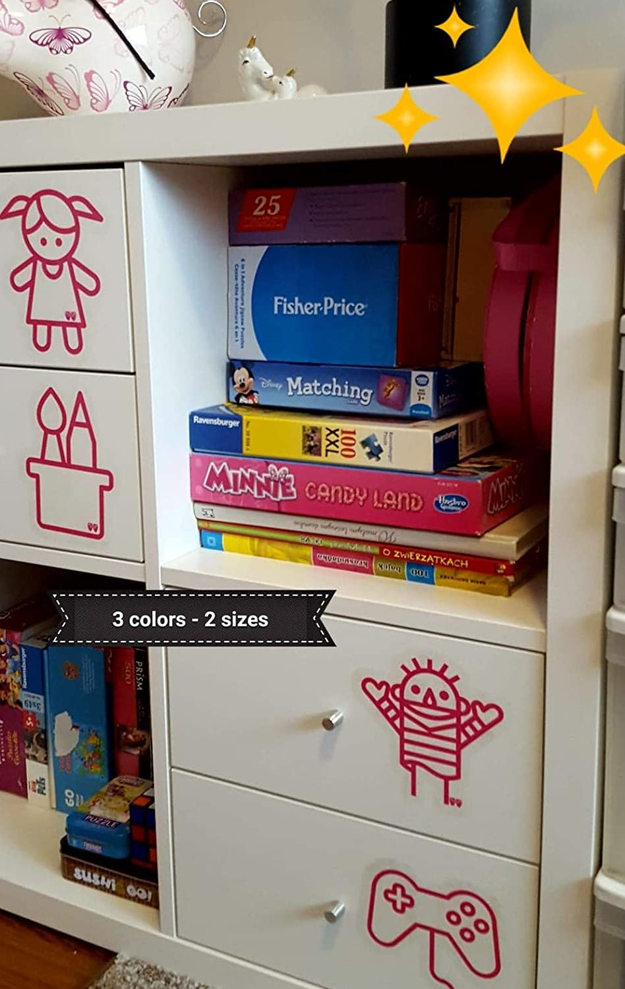

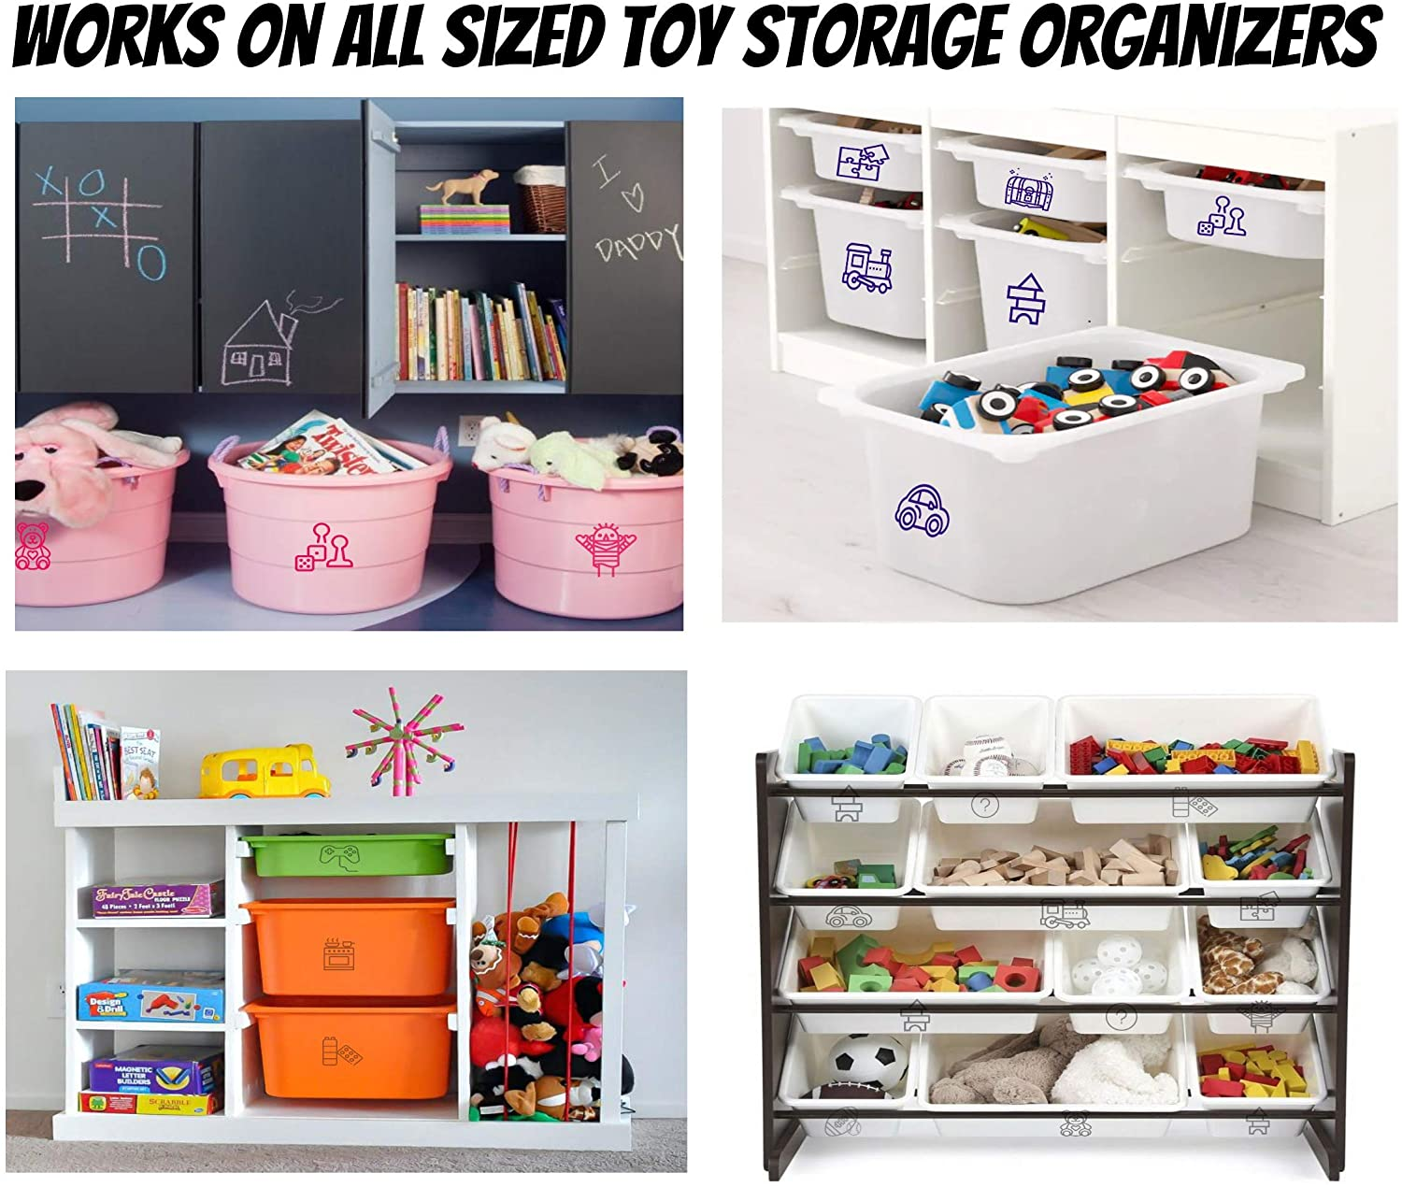

These transparent [stickers](https://www.amazon.com/dp/B07QX9QL7D?ref=myi_title_dp) with fun and simple icons come in 2 sizes (Small or Large). So if you have a small or big bin/basket, that’s not a problem at all. You can mix some colors too because there are 3 colors available (Gray, Pink or Blue) to choose from!

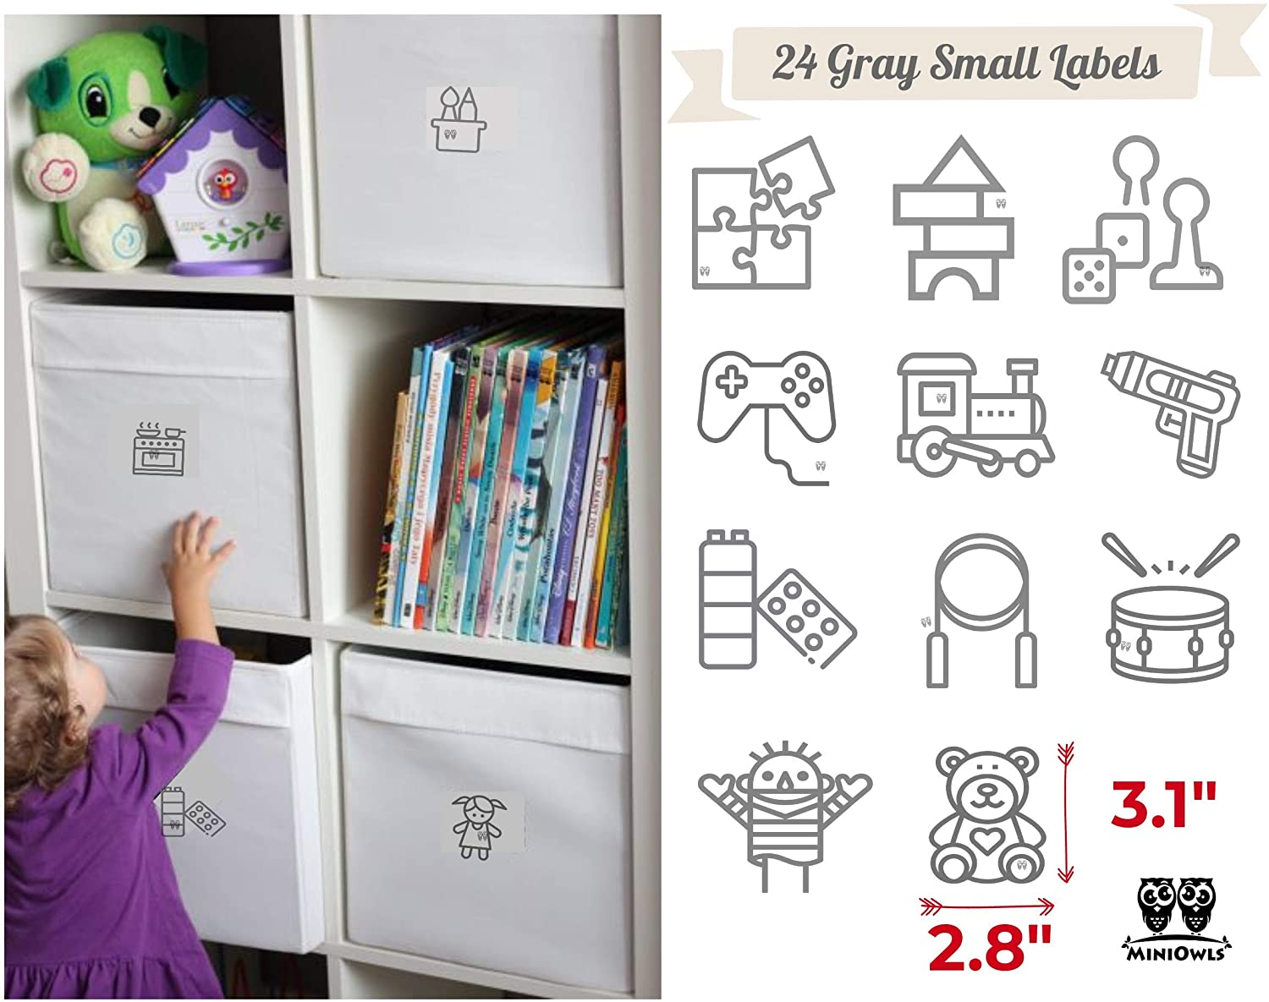

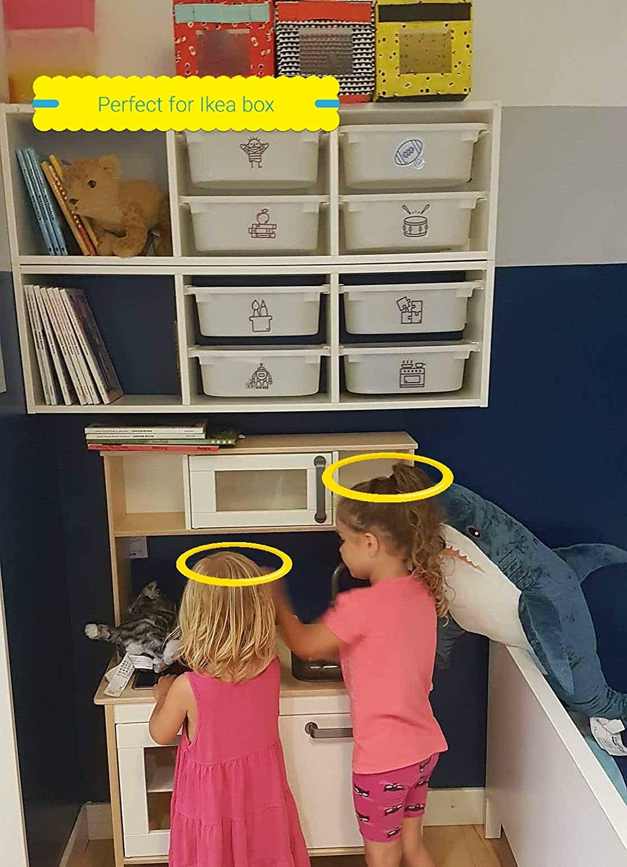

I couldn’t be happier seeing my kids cleaning up their playroom and finally clutter free! I can absolutely say this [labeling system](https://www.amazon.com/dp/B07QX9QL7D?ref=myi_title_dp) works and is an effective way to eliminate daily chaos.

Tip: You can print word labels to stick together with the [toy icon labels](https://www.amazon.com/dp/B07QX9QL7D?ref=myi_title_dp) so young kiddos will learn how to read! 🠇🠇

